**Prometheus-Grafana-Alertmanager Installation guide on k8s Cluster**

1. Installation and Setup

Install the kube-prometheus stack, a collection of Kubernetes manifests, Grafana dashboards, and Prometheus rules, Alert manager, Alert manager rules, Node-exporter combined with documentation and scripts to provide easy to operate end-to-end Kubernetes cluster monitoring with Prometheus using the Prometheus Operator. See the [kube-prometheus](https://github.com/prometheus-operator/kube-prometheus) for details about components, dashboards, and alerts.

**Repository Info:**

1. Add Repo:

helm repo add prometheus-community https://prometheus-community.github.io/helm-charts

helm repo update

1. Download values file :

helm show values prometheus-community/kube-prometheus-stack > prometheus.yaml

Note: Once it downloads , we need to configured it according to our use case

**Configuring values file (prometheus.yaml) of Thanos with S3:**

1. To enable thanos sidecar, we need to edit thanos configuration in prometheusSpec section

And also add thanos objectstoreconfig as a secret as follows:

thanos:

objectStorageConfig:

key: "thanos.yaml"

name: "thanos-objstore-config"

Note : Need to create kubernetes secret for [Example objectStoreConfig](https://thanos.io/tip/thanos/storage.md/#s3)

thanos.yaml:

type: S3

config:

bucket: "bucket-name"

endpoint: "s3.amazonaws.com"

access_key: ""

secret_key: ""

region: "us-east-1"

insecure: false

signature_version2: false

put_user_metadata: {}

http_config:

idle_conn_timeout: 0s

response_header_timeout: 0s

insecure_skip_verify: false

trace:

enable: false

part_size: 0

Write the command in terminal to create secret:

kubectl create secret generic thanos-objstore-config –from-file=thanos.yaml

**Install Helm chart :**

helm install [RELEASE_NAME] prometheus-community/kube-prometheus-stack –f prometheus.yaml

**Check logs of prometheus stack:**

kubectl logs –f [Prometheus stack pod_name] –c thanos-sidecar

After applying above command will get result like below:

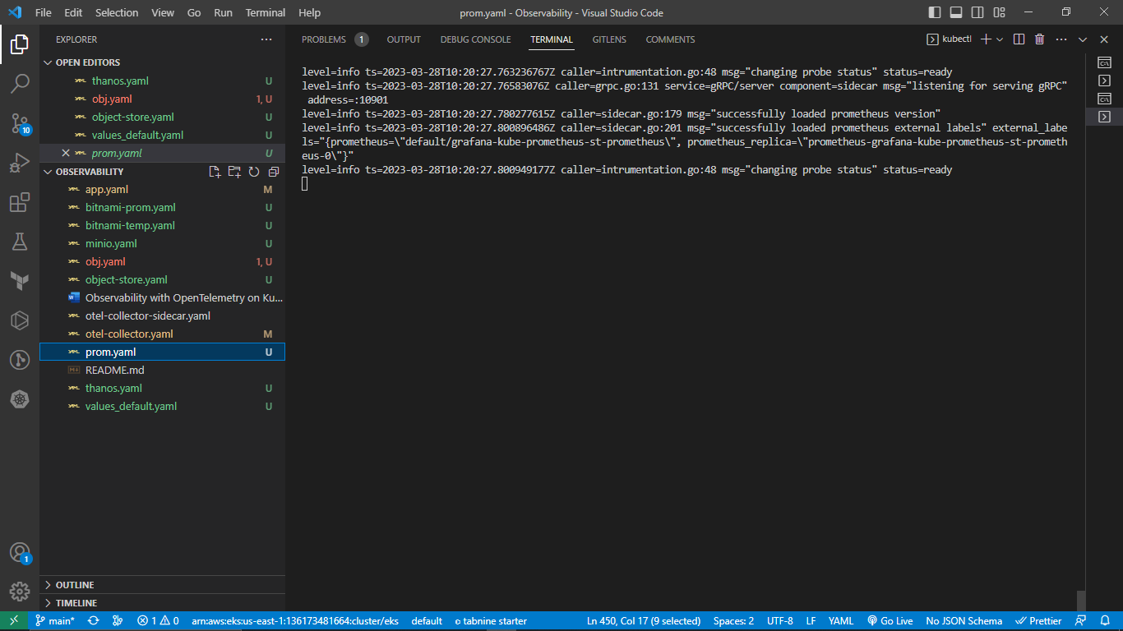

The maximum number of bytes of storage blocks to retain. The oldest data will be removed first. Defaults to 0 or disabled. Units supported: B, KB, MB, GB, TB, PB, EB. Ex: "512MB". Based on powers-of-2, so 1KB is 1024B. Only the persistent blocks are deleted to honor this retention although WAL and m-mapped chunks are counted in the total size. So the minimum requirement for the disk is the peak space taken by the wal (the WAL and Checkpoint) and chunks_head (m-mapped Head chunks) directory combined (peaks every 2 hours).

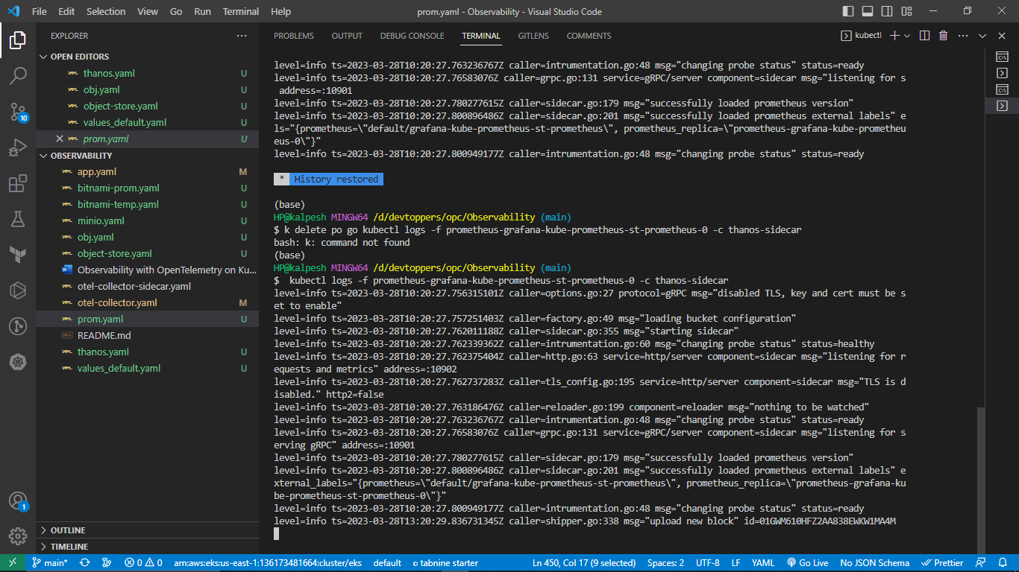

From the above image, thanos-sidecar will upload the data after every 3 hours and store the data in S3 bucket

( See the timings from the above image ) and data will get upload in S3 bucket (See below image)

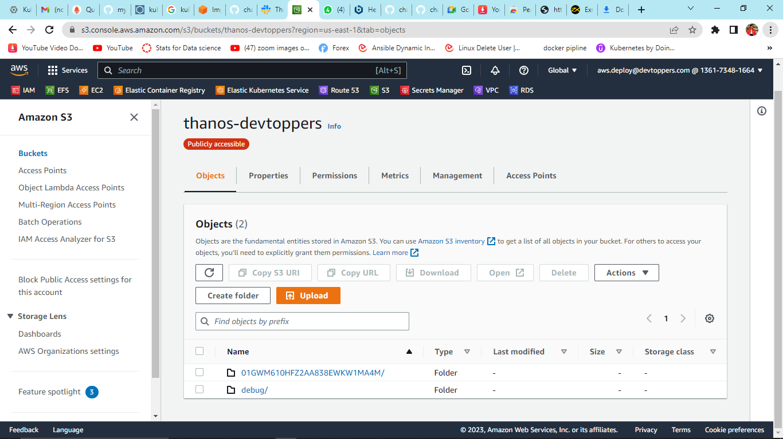

After successful chart deployment we will get the Prometheus dashboard like below by accesing its service

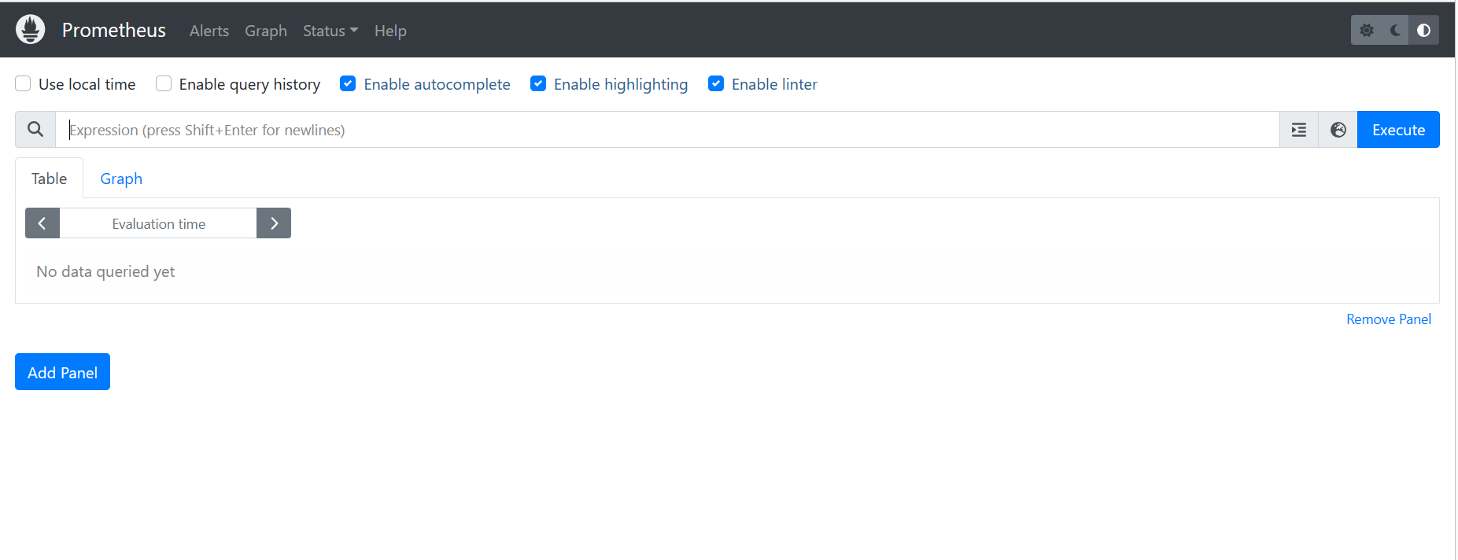

Click on Alerts and get the alertsrules that we have set in prometheus.yaml file

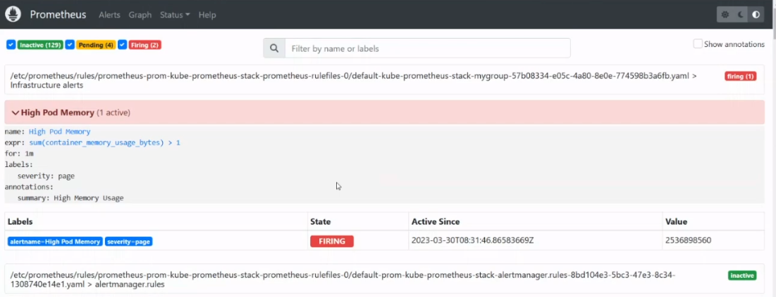

**OR** Access the Alertmanger dashboard by accessing its service to see the alerts in alerts section

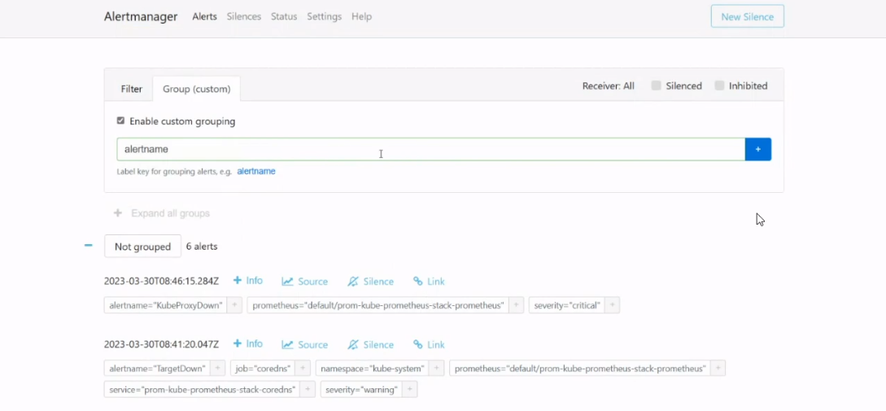

**Configuration of Alertmanager with Slack and Opsgenie:**

1. **To add custom Prometheus rules, In order to add the additional Prometheus rules section,**

**set custom Prometheus rules**

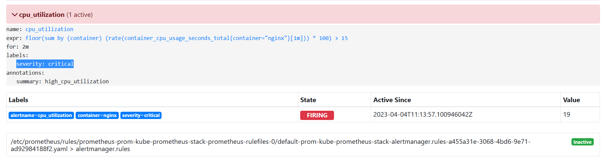

**OR to make our own additional custom alert rules ,we can create CRD’s which is also a better option. For example,**

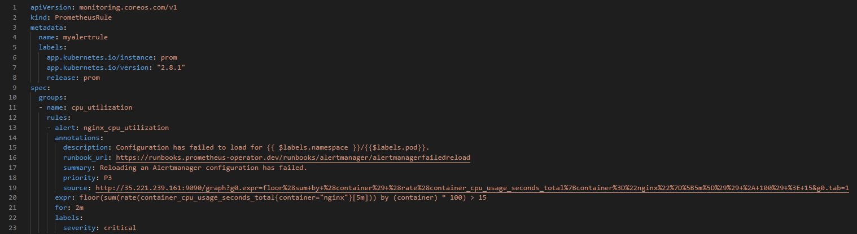

**To override the default alertmanager config we need to create an alertmanager config CRD in such a way that it will integrate alertmanager with slack and opsgenie as follows**

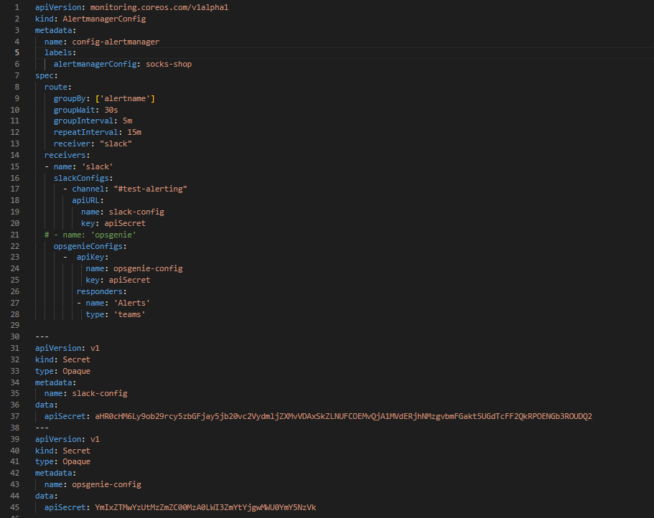

For **slack**,

1. Create a channel on slack

2. Create an app from **Manage Apps** > Click on **Create App** > Name the App > Mention created channel name > Copy the **Webhook URL** > Encode the URL from **base64** > Copy the the encoded value and paste in **apisecret.**

For **opsgenie**,

1. Create an account on Opsgenie

2. Select the product as **opsgenie cloud** > Click on **Teams** > Add teams>Give a team name >

Add the users for responder roles.

3. Click on your team > Click on **Add Integration** > Search and Select **Prometheus** > Copy the **api key** > Encode the api key from **base64** > Paste it in **apisecret**.

After sometime of groupinterval will receive the alerts in Alerts section

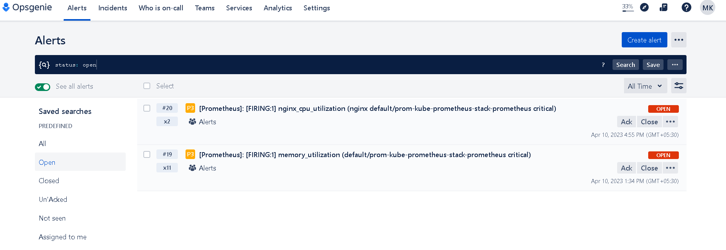

After applying above alertmanager crd config, we need mention above CRD’s name in alertmanager.spec.alertmanagerConfiguration Section of Kube-prometheus-stack helm chart.

1. For Demo purpose we have deployed nginx pod and for cpu_utilization we have apply stress of 1 core cpu .
2. Once threshold limit reaches , it will fire an alerts and we can see in prometheus alerts section .